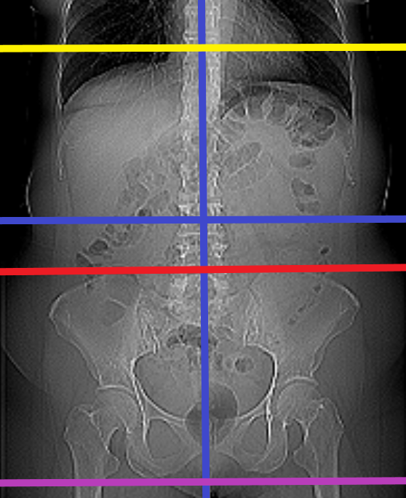
Computed Tomography (CT) Scans

Exam Reference/ Protocol Guidelines

Abdomen and Pelvis

The blue lines mark the four quadrants: Right Upper, Right Lower, Left Upper, Left Lower

A CT Abdomen begins at the yellow line and ends at the red line.

A CT Pelvis begins at the red line and ends at the purple line.

A CT Abdomen & Pelvis begins at the yellow line and ends at the purple line.

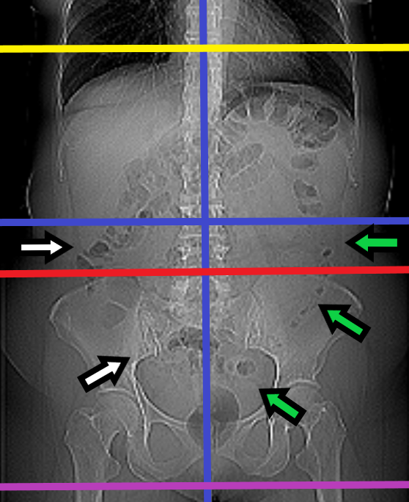
A CT Abdomen excludes the lower portions of the large and small intestines, where the appendix and common sites for diverticulitis are often found. The white arrows in the diagram point to common sites for the appendix, and the green arrows point to commons sites for diverticulitis.

Body Part | Indications | Exam Needed | Contrast | CPT Code | Additional Info
Abdomen/Pelvis | Abdominal Pain  Appendicitis  Bowel Obstruction  Diverticulitis  Umbilical/Ventral Hernia | CT Abdomen & Pelvis | PRN or With | 74177
Abdomen/Pelvis | Kidney Stone  Flank Pain  Painful Hematuria | CT Abdomen & Pelvis | PRN or Without | 74176
Abdomen | Upper abdominal pain  Splenic lesion | CT Abdomen | PRN or With | 74160
Pelvis | Pelvic pain  Inguinal Hernia | CT Pelvis | PRN or With | 72193
Pelvis | Hip pain | CT Pelvis | PRN or  Without | 72192
Liver | Liver mass/lesion  Cirrhosis  Hepatoma | CT Abdomen or  CT Abdomen & Pelvis | PRN or  Without & With | 74170 or  74178
Pancreas | Pancreatic mass/lesion  Pancreatitis | CT Abdomen or  CT Abdomen & Pelvis | PRN or  Without & With | 74170 or  74178
Kidneys | Renal mass | CT Abdomen or  CT Abdomen & Pelvis | PRN or  Without & With | 74170 or  74178
Kidneys/Bladder | Painless/Persistent Hematuria  Bladder cancer | CT Abdomen & Pelvis | PRN or  Without & With | 74178  76377 (3D) | “IVP protocol”  Add 3D
Adrenal glands | Adrenal nodule/mass | CT Abdomen | PRN or  Without & With | 74170 or  74178
Small Intestines | Crohn’s disease  Inflammatory bowel disease  Small bowel lesion  Iron-deficiency anemia | CT Abdomen & Pelvis | PRN or  With | 74177 | “Enterography protocol”
GI System | GI Bleeding | CT Angio Abdomen & Pelvis | With and/or Without | 74174
Aorta | Aortic aneurysm/dissection | CT Angio Chest or  CT Angio Chest & Abdomen or  CT Angio Chest & Abdomen & Pelvis or  CT Angio Abdomen or  CT Angio Abdomen & Pelvis | With and/or Without | 71275 (chest)  74175 (abdomen)  74174 (Abdomen Pelvis) | Varies based on region of interest
Renal Arteries  Celiac Artery | Renal artery stenosis/aneurysm  Celiac artery stenosis/aneurysm | CT Angio Abdomen | With and/or Without | 74175
Mesenteric Arteries | Ischemic bowel  Mesenteric artery occlusion  Mesenteric ischemia | CT Angio Abdomen & Pelvis | With and/or Without | 74174
Chest, Abdomen, & Pelvis | Trauma  Malignancy  Sepsis | CT Chest, Abdomen, & Pelvis | PRN or With | 71260 and  74177

